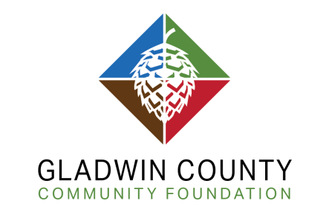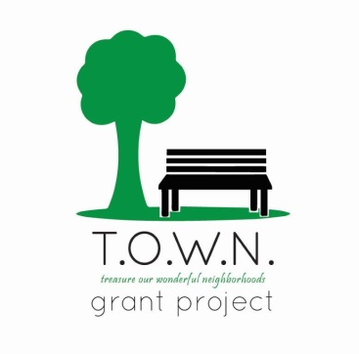
T.O.W.N. (Treasure Our Wonderful Neighborhoods)
Grant Application
Note: please contact GCCF Program Officer Melissa Kesterson prior to applying.
Contact info: 989.839.9661 or mkesterson@midlandfoundation.org

- Legal name of the organization applying (identical to name on the IRS Tax Determination Letter)

- Common organization name (if different from legal name)

- Employment Identification Number

- Application Number (provided by program officer during initial contact to discuss proposal)

- Contact Information (address, city, state, zip, telephone, email)

- Contact person for request (name, phone number and email)

- Dollar amount requested

- Total project cost

- Project title

- Project date

- Project summary (a brief statement, 75 words or less, describing your project)

- What is your plan for engaging your community in this project?

__________________________________________________________________________________________
Project Budget
Revenue | Expenses
GCCF Grant $2,000 (pending) | Equipment
In Kind Donations | Supplies
Cash Donations | Labor
Community Member Engagement | Other Misc. Expenses
Total Revenue | Total Expenses

Notification could be given within six weeks after grant deadline.

Gladwin County Community Foundation

76 Ashman Circle Midland MI 48640 989-839-9661 www.gladwinfoundation.org

